SQL Queries
- To select the Table
SQL > select * from financial_loan_data_excel

- To calculate for total loan application
SQL > select count(*) as Total_loan_application from financial_loan_data_excel
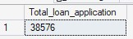

- To calculate for total funded amount
SQL > select sum(loan_amount) as Total_funded_application from financial_loan_data_excel


- To calculate for total funded application
SQL > select sum(total_payment) as Total_funded_amount from financial_loan_data_excel


- To calculate for average annual income
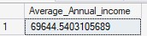
SQL > select AVG(annual_income) as Average_Annual_income from financial_loan_data_excel

- To calculate for average interest rate

SQL > select AVG(int_rate *100.0) as Average_int_rate from financial_loan_data_excel

- To calculate for average Dti
SQL > select AVG(dti *100.0) as Average_Dti from financial_loan_data_excel
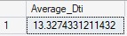

- To calculate for the PMTD for Total applications, total funded amount, Total funded application, Average int rate, Average Dti
SQL > select * from (select MONTH(last_payment_date) as month, count (id) as Total_application, sum(loan_amount) as Total_funded_amount, sum(total_payment)
as Total_funded_application,AVG(int_rate)*100 as Average_int_rate, AVG(dti)*100 as Average_dti from financial_loan_data_excel
group by MONTH(last_payment_date) order by MONTH(last_payment_date) offset 8 rows fetch next 1 row only)t

- To calculate for the MTD for Total applications, total funded amount, Total funded application, Average int rate, Average Dti
SQL > select * from (select MONTH(last_payment_date) as month, count (id) as Total_application, sum(loan_amount) as Total_funded_amount, sum(total_payment)
as Total_funded_application,AVG(int_rate)*100 as Average_int_rate, AVG(dti)*100 as Average_dti from financial_loan_data_excel
group by MONTH(last_payment_date) order by MONTH(last_payment_date) offset 9 rows fetch next 1 row only)t

- Calculate total loan application by emp_lenght
SQL> select emp_length, count(id) as Total_application from financial_loan_data_excel group by emp_length order by emp_length
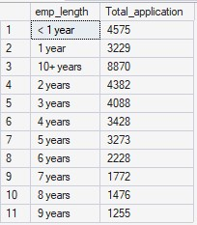

- Calculate total loan application based on Purpose
SQL> select purpose, count(id) as Total_loan_application from financial_loan_data_excel group by purpose order by Total_loan_application

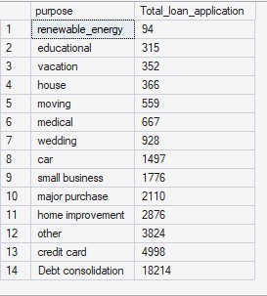
- Total loan application based on Home ownership
SQL> select home_ownership, count(id) as Total_loan_application from financial_loan_data_excel group by home_ownership
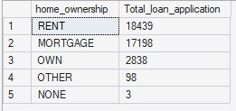
order by Total_loan_application desc

- Total loan application based on Verification
SQL> select verification_status, count(id) as Total_loan_application from financial_loan_data_excel group by verification_status
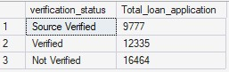
order by Total_loan_application

- Total loan application, Total funded amount, Total funded application, avg_nt_rate, avg_Dti based on loan status
SQL> select loan_status, count (id) as Total_application, sum(loan_amount) as Total_funded_amount, sum(total_payment)
as Total_funded_application,AVG(int_rate)*100 as Average_int_rate,AVG(dti)*100 as average_dti from financial_loan_data_excel
group by loan_status order by Total_application desc

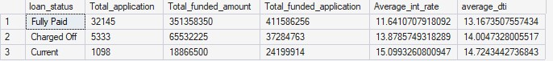
- Loan application on monthly Basis
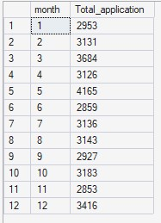
SQL> select MONTH(last_payment_date) as month, count (id) as Total_application from financial_loan_data_excel group by MONTH(last_payment_date) order by MONTH(last_payment_date)

- Total loan application based on States
SQL> select address_state, count(*) as Total_application from financial_loan_data_excel group by address_state

- Loan verification status based on term
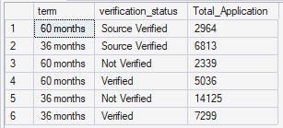
SQL> select term,verification_status,count(*) as Total_Application from financial_loan_data_excel group by term,verification_status
- Total loan application based on grade
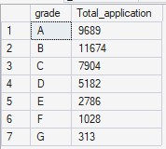
SQL> select grade, count(*) as Total_application from financial_loan_data_excel group by grade order by grade

- Loan application status quarterly
SQL> select datepart(quarter,last_payment_date) as quarter,loan_status, sum(case when loan_status in ('fully Paid','Current')
then 1 else 0 end) as Good_loan, sum(case when loan_status ='Charged Off'
then 1 else 0 end) as Bad_loan from financial_loan_data_excel group by DATEPART(quarter,last_payment_date),loan_status
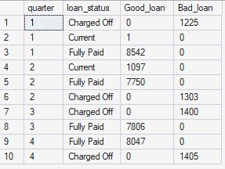
order by DATEPART(quarter,last_payment_date)

- Top 10 emp_Title based on total loan application
SQL> select top 10 emp_title, count(emp_title) as Total_application from financial_loan_data_excel group by emp_title order by
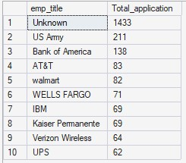
Total_application desc

21. Top 5 Grade with high annual_income earner
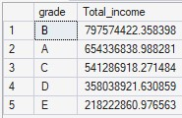
SQL> select top 5 grade, sum(annual_income) as Total_income from financial_loan_data_excel group by grade order by Total_income desc

- Top 5 Purpose with the least annual_income
SQL> select top 5 purpose,sum(annual_income) as Total_income from financial_loan_data_excel group by purpose order by Total_income
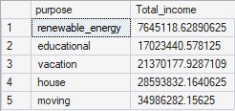

- Top 5 Emp Title with the highest annual_income
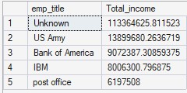
SQL> select top 5 emp_title,sum(annual_income) as Total_income from financial_loan_data_excel group by emp_title order by Total_income desc

